AI ASSITANT
LAB ASSIGNMENT :8.1
NAME: SRIJA
BATCH:44
2303A52412
Task Description #1 (Password Strength Validator – Apply AI in
Security Context)
Prompt : Apply AI to generate at least 3 assert test cases for
is_strong_password(password) and implement the validator
function
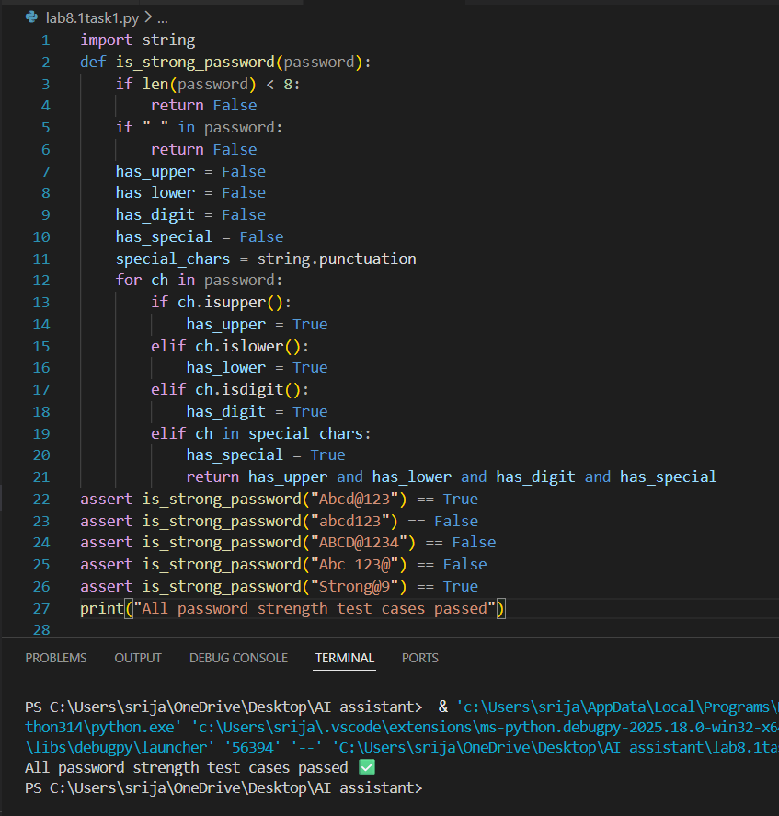

Task Description #2 (Number Classification with Loops – Apply
AI for Edge Case Handling)
prompt: Use AI to generate at least 3 assert test cases for a
classify_number(n) function. Implement using loops.
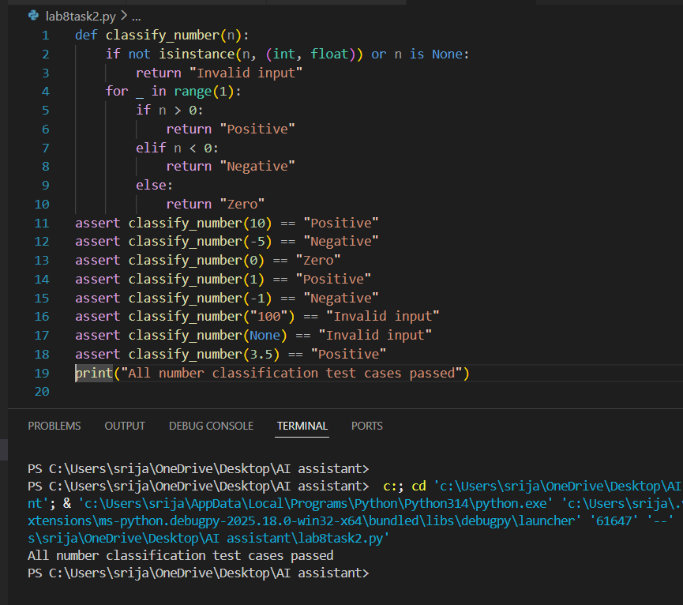
Task Description #3 (Anagram Checker – Apply AI for String
Analysis)
prompt: Use AI to generate at least 3 assert test cases for
is_anagram(str1, str2) and implement the function.
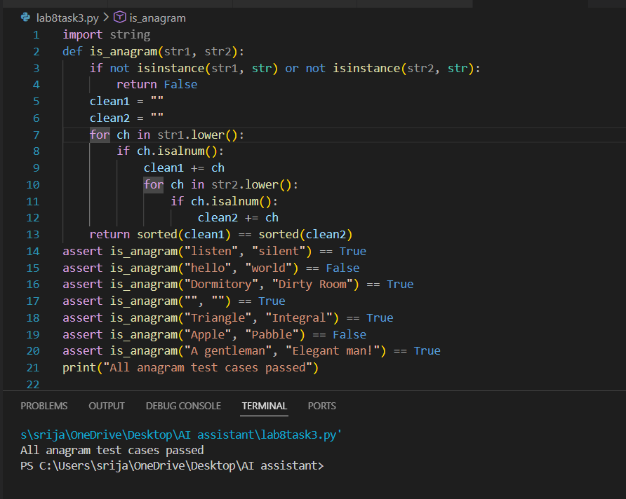
Task Description #4 (Inventory Class – Apply AI to Simulate Real-
World Inventory System)
prompt: Ask AI to generate at least 3 assert-based tests for an
Inventory class with stock management.
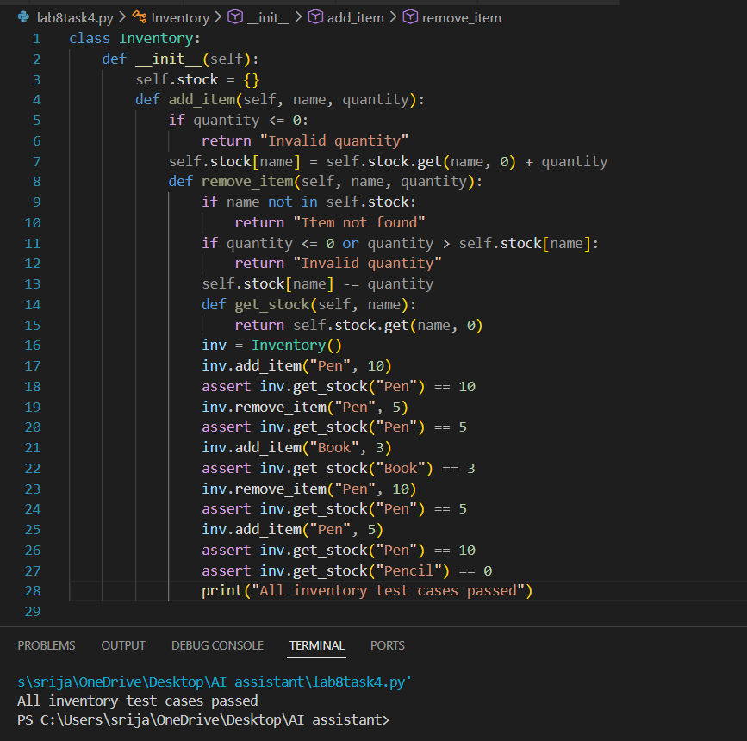

Task Description #5 (Date Validation & Formatting – Apply AI for
Data Validation)
prompt: Use AI to generate at least 3 assert test cases for
validate_and_format_date(date_str) to check and convert
dates.
